**ASM Laboratory**



Name: **Soham Das**

Section: **A1**

Roll No: **002311001004**

**IT-UG2**

1. Write an Assembly Language Program to add 3 X 3 matrices. Assume the matrices are stored in the form of lists (row wise). First matrix is stored from DS:0030H and the second matrix is stored from DS:0040.Store the result of the addition in the third lists starting from DS:0050H.

.model small

.stack 100h

.data

.code

main proc

mov ax,@data

mov es,ax

mov ds, ax

mov si,0030h

mov di,0040h

mov bx,0050h

mov cx,0009h

l1:

mov al,[si]

add al,[di]

mov [bx],al

inc di

inc bx

inc si

loop l1

int 03h

mov ah,4ch

int 21h

main endp

end main

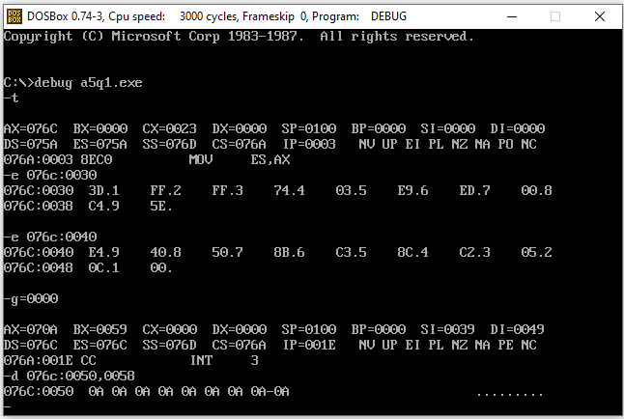

2. Write an Assembly Language Program to convert an eight bit binary number stored in DS:0030H into its equivalent BCD number. Stored the result in DS:0040H.

; Problem 2

dosseg

.model small

.stack 100h

.data

.code

main proc

mov ax,@data

mov es,ax

mov ds, ax

mov si,0030h

mov dx,0000h

mov ax,0000h

mov cl,[si]

l2:

cmp cl,00

jz l1

dec cl

mov al,dl

add al,01h

daa

mov dl,al

mov al,dh

adc al,00h

daa

mov dh,al

jmp l2

l1:

mov si,0040h

mov[si],dx

int 03h

mov ah,4ch

int 21h

main endp

end main

3. Write an Assembly program to convert a BCD number stored in DS:0030H into its equivalent hexadecimal number. Stored the result in DS:0040H.

; Problem 3

dosseg

.model small

.stack 100h

.data

.code

main proc

mov ax,@data

mov ds,ax

mov si,0030h

mov di,0040h

mov al,[si]

mov bl,al

and al,0f0h

mov cl,04h

ror al,cl

mov dl,0ah

mul dl

mov dx,ax

mov al,bl

and al,0fh

mov ah,00h

add ax,dx

mov [di],ax

int 03h

mov ah,4ch

int 21h

main endp

end main

4. Write an Assembly program to convert a binary number stored in DS:0030H into its equivalent gray code. Stored the result in DS:0040H.

dosseg

.model small

.stack 100h

.data

.code

main proc

mov ax,@data

mov ds,ax

mov si,0030h

mov di,0040h

mov al,[si]

mov dl,[si]

clc

rcr al,01

xor al,dl

mov [di],al

int 03h

mov ah, 4ch

int 21h

main endp

5. Write an Assembly program to find the factorial of a number stored in DS:0030H. Stored the result in DS:0040H.

dosseg

.model small

.stack 100h

.data

.code

main proc

mov ax,@data

mov ds,ax

mov si,0030h

mov di,0040h

mov bx,0000h

mov ax,0000h

mov al,[si]

mov cx,[si]

mov bl,al

l1:

dec bl

cmp bl,00h

jz l2

mul bx

mov dx,ax

loop l1

l2: mov [di],dx

int 03h

mov ah, 4ch

int 21h

main endp

end main

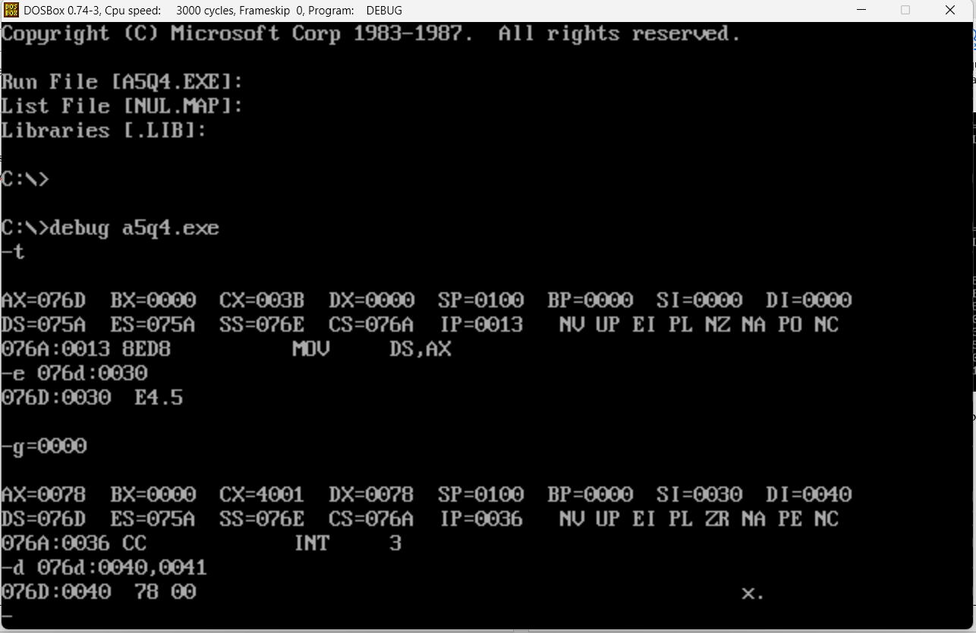

(note: 78 in hex is 120 in decimal and 5! = 120)